Phase 6: User Interface Development
Debug Log Analysis and Bug Fixing in Salesforce Apex
- Designing a Developer Console-Style UI
  - Create a Lightning App Page or LWC (Lightning Web Component) layout for viewing Apex logs.
  - Provide sections such as:
    - Upload Log File
    - Select Existing Log
    - Run Replay Debugger
    - View Debug Timeline & Events
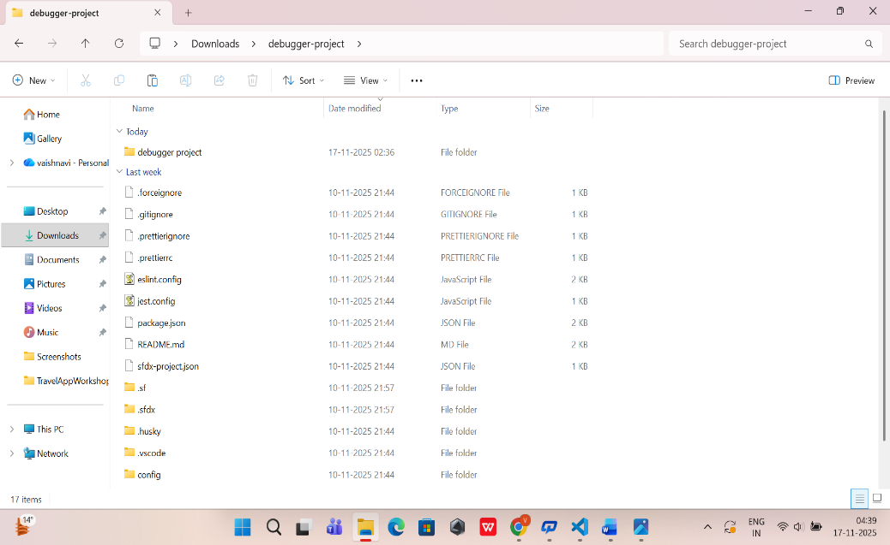
- Developing
  - Build components for:
    - Log Upload Component – allows users to upload .log files generated by Salesforce.
    - Log List Viewer – displays stored logs with date/time and type.
    - Debugger Action Panel – provides buttons such as Replay, Step Over, Step Into, Step Out (simulated for demo purposes).
    - Debug Result Viewer – shows output like variable values and execution steps.
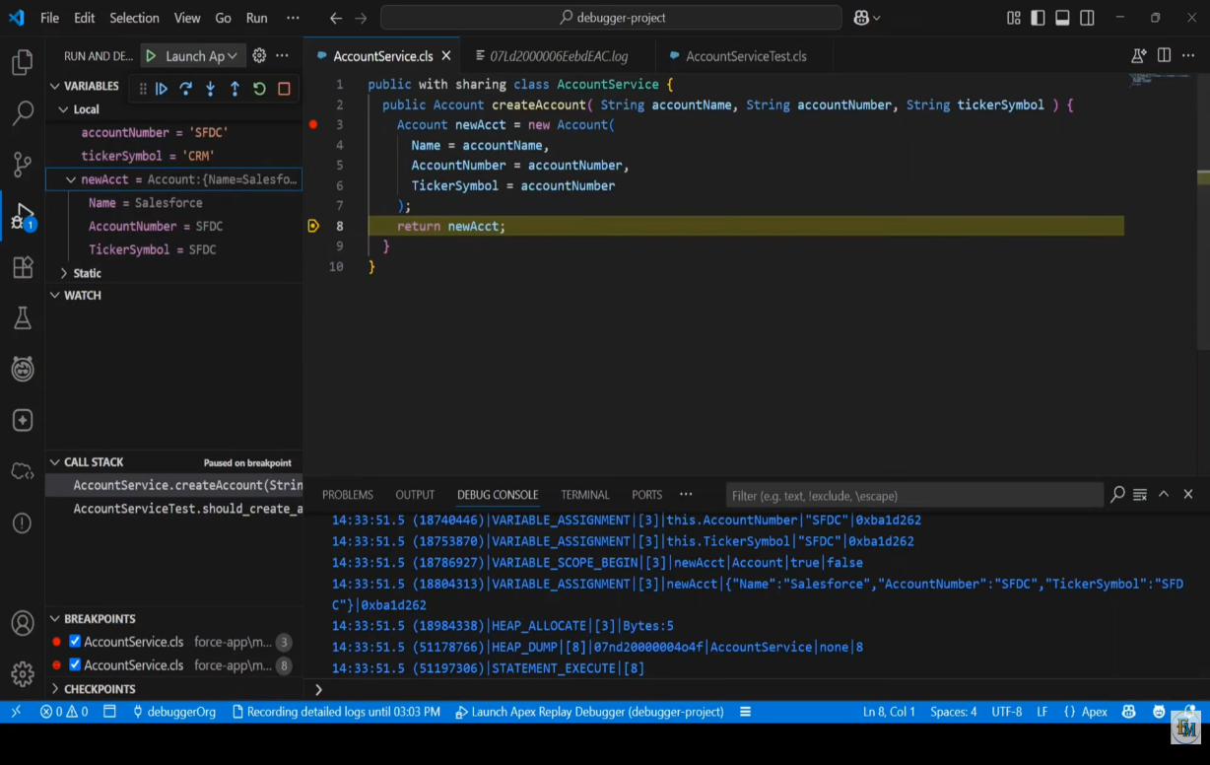

- Connecting UI With Backend Apex
  - LWC components call Apex methods to:
    - Store log files in a custom object.
    - Process log content and extract debug events.
    - Return step-by-step debug information back to the UI.
- UI for Data Visualization
  - Display debugging steps in structured formats like:
    - Tables (execution order)
    - Highlighted code segments
    - Error-focused sections (if any)
- Ensuring Ease of Use
  - Clear labels and simple instructions for developers.
  - Intuitive navigation so users can easily:
    - Upload → Run → Analyze logs.

